Enduromax DCC2003SM/36/SV Overhead Door Closer

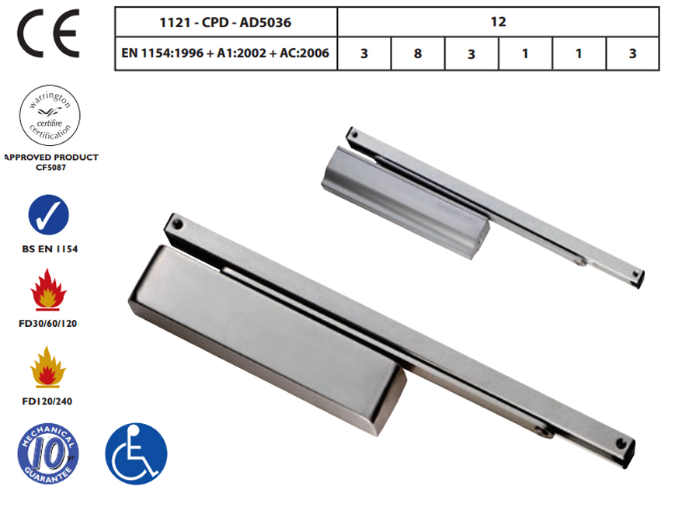
Product Details
Suitable for Industrial, Domestic or Commercial Use
Dimensions: 236mm x 59mm
Available Finishes:
- Silver Standard (Without Cover Plate)
- Electro Brass (Door closer and Plated arm, Fixings and Cover pack)
- Polished Nickel Plated (Door closer and Plated arm, Fixings and Cover pack)
- Satin Nickel Plated (Door closer and Plated arm, Fixings and Cover pack)
- Silver (Door closer and Plated arm, Fixings and Cover pack)
Closing Force EN Size 3
Efficiency 77%
Max Door Width: 950mm
Max Weight: 60Kg
Angle Of Opening Max 120 Degrees
Suitable For Left Hand Or Right Hand Use
Adjustable Closing Speed
Adjustable Latching Speed
10 year Mechanical Guarantee
Slide Channel
Slimline Body
Suitable for Fire Doors Rated to FD30/60/120/240
Meets Recommendations Of BS 8300 (DDA Compliant)

